Name:________________________________________________
Period:______ Date:____________________________

What Is Conformity? By Kendra Cherry

Question: What Is Conformity?
Answer:
Conformity involves changing your behaviors in order to "fit in" or "go along" with the people around you. In some cases, this social influence might involve agreeing with or acting like the majority of people in a specific group, or it might involve behaving in a particular way in order to be perceived as "normal" by the group.

Definitions of Conformity
Psychologists have proposed a variety of definitions to encompass the social influence that conformity exerts.
Essentially, conformity involves giving in to group pressure. Some other definitions include:
- "Conformity is the most general concept and refers to any change in behavior caused by another person or group; the individual acted in some way because of influence from others. Note that conformity is limited to changes in behavior caused by other people; it does not refer to effects of other people on internal concepts like attitudes or beliefs... Conformity encompasses compliance and obedience, because it refers to any behavior that occurs as a result of others' influence - no matter what the nature of the influence."
- (Breckler, Olson, & Wiggins, Social Psychology Alive, 2006)
- "Conformity can be defined as yielding to group pressures, something which nearly all of us do some of the time. Suppose, for example, you go with friends to see a film. You didn't think the film was very good, but all your friends thought that it was absolutely brilliant. You might be tempted to conform by pretending to agree with their verdict on the film rather than being the odd one out." (Eysenck, Psychology: An International Perspective,2004)

Why Do We Conform?
Researchers have found that people conform for a number of different reasons. In many cases, looking to the rest of the group for clues for how we should behave can actually be helpful. Other people might have greater knowledge or experience than we do, so following their lead can actually be instructive.
In other cases, we conform to the expectations of the group in order to avoid looking foolish. This tendency can become particularly strong in situations where we aren't quite sure how to act or where the expectations are ambiguous.
Deautsch and Gerard (1955) identified two key reasons why people conform: informational influence and normative influence.
Informational influence happens when people change their behavior in order to be correct. In situations where we are unsure of the correct response, we often look to others who are better informed and more knowledgeable and use their lead as a guide for our own behaviors. In a classroom setting, for example, this might involve agreeing with the judgments of another classmate who you perceive as being highly intelligent.
Normative influence stems from a desire to avoid punishments (such as going along with the rules in class even though you don't agree with them) and gain rewards (such as behaving in a certain way in order to get people to like you).

Types of Conformity
As mentioned previously, normative and informational influences are two important types of conformity, but there are also a number of other reasons why we conform. The following are some of the major types of conformity.
- Normative conformity involves changing one's behavior in order to fit in with the group.
- Informational conformity happens when a person lacks knowledge and looks to the group for information and direction.
- Identification occurs when people conform to what is expected of them based upon their social roles. Zimbardo's famous Stanford Prison Experiment is a good example of people altering their behavior in order to fit into their expected roles.
- Compliance involves changing one's behavior while still internally disagreeing with the group.
- Internalization occurs when we change our behavior because we want to be like another person.

Research and Experiments on Conformity
Conformity is something that happens regularly in our social worlds. Sometimes we are aware of our behavior, but in many cases it happens without much thought or awareness on our parts. In some cases, we go along with things that we disagree with or behave in ways that we know we shouldn't. Some of the best-know experiments on the psychology of conformity deal with people going along with the group, even when they know the group is wrong.
- Jenness' 1932 Experiment: In one of the earliest experiments on conformity, Jenness asked participants to estimate the number of beans in a bottle. They first estimated the number individually and then later as a group. After they were asked as a group, they were then asked again individually and the experimenter found that their estimates shifted from their original guess to closer to what other members of the group had guessed.
- Sherif's Autokinetic Effect Experiments: In a series of experiments, Muzafer Sherif asked participants to estimate how far a dot of light in a dark room moved. In reality the dot was static, but it appeared to move due to something known as the autokinetic effect. Essentially, tiny movements of the eyes make it appear that a small spot of light is moving in a dark room. When asked individually, the participants' answers varied considerably. When asked as part of a group, however, Sherif found that the responses converged toward a central mean. Sherif's results demonstrated that in an ambiguous situation, people will conform to the group, an example of informational influence.
- Asch's Conformity Experiments: In this series of famous experiments, psychologist Solomon Asch asked participants to complete what they believed was a simple perceptual task. They were asked to choose a line that matched the length of one of three different lines. When asked individually, participants would choose the correct line. When asked in the presence of confederates who were in on the experiment and who intentionally selected the wrong line, around 75 percent of participants conformed to the group at least once. This experiment is a good example of normative influence; participants changed their answer and conformed to the group in order to fit in and avoid standing out.

Factors That Influence Conformity
- The difficulty of the task: Difficult tasks can lead to both increased and decreased conformity. Not knowing how to perform a difficult task makes people more likely to conform, but increased difficulty can also make people more accepting of different responses, leading to less conformity.
- Individual differences: Personal characteristics such as motivation to achieve and strong leadership abilities are linked with a decreased tendency to conform.
- The size of the group: People are more likely to conform in situations that involve between three and five other people.
- Characteristics of the situation: People are more likely to conform in ambiguous situations where they are unclear about how they should respond.
- Cultural differences: Researchers have found that people from collectivist cultures are more likely to conform.

Examples of Conformity
- A teenager dresses in a certain style because he wants to fit in with the rest of the guys in his social group.
- A 20-year-old college student drinks at a sorority party because all her friends are doing it and she does not want to be the odd one out.
- A woman reads a book for her book club and really enjoys it. When she attends her book club meeting, the other members all disliked the book. Rather than go against the group opinion, she simply agrees with the others that the book was terrible.
- A student is unsure about the answer to a particular question posed by the teacher. When another student in the class provides an answer, the confused student concurs with the answer believing that the other student is smarter and better informed.

Name:___________________________________________
Period:_____ Date:____________________
WHY DO WE CONFORM?
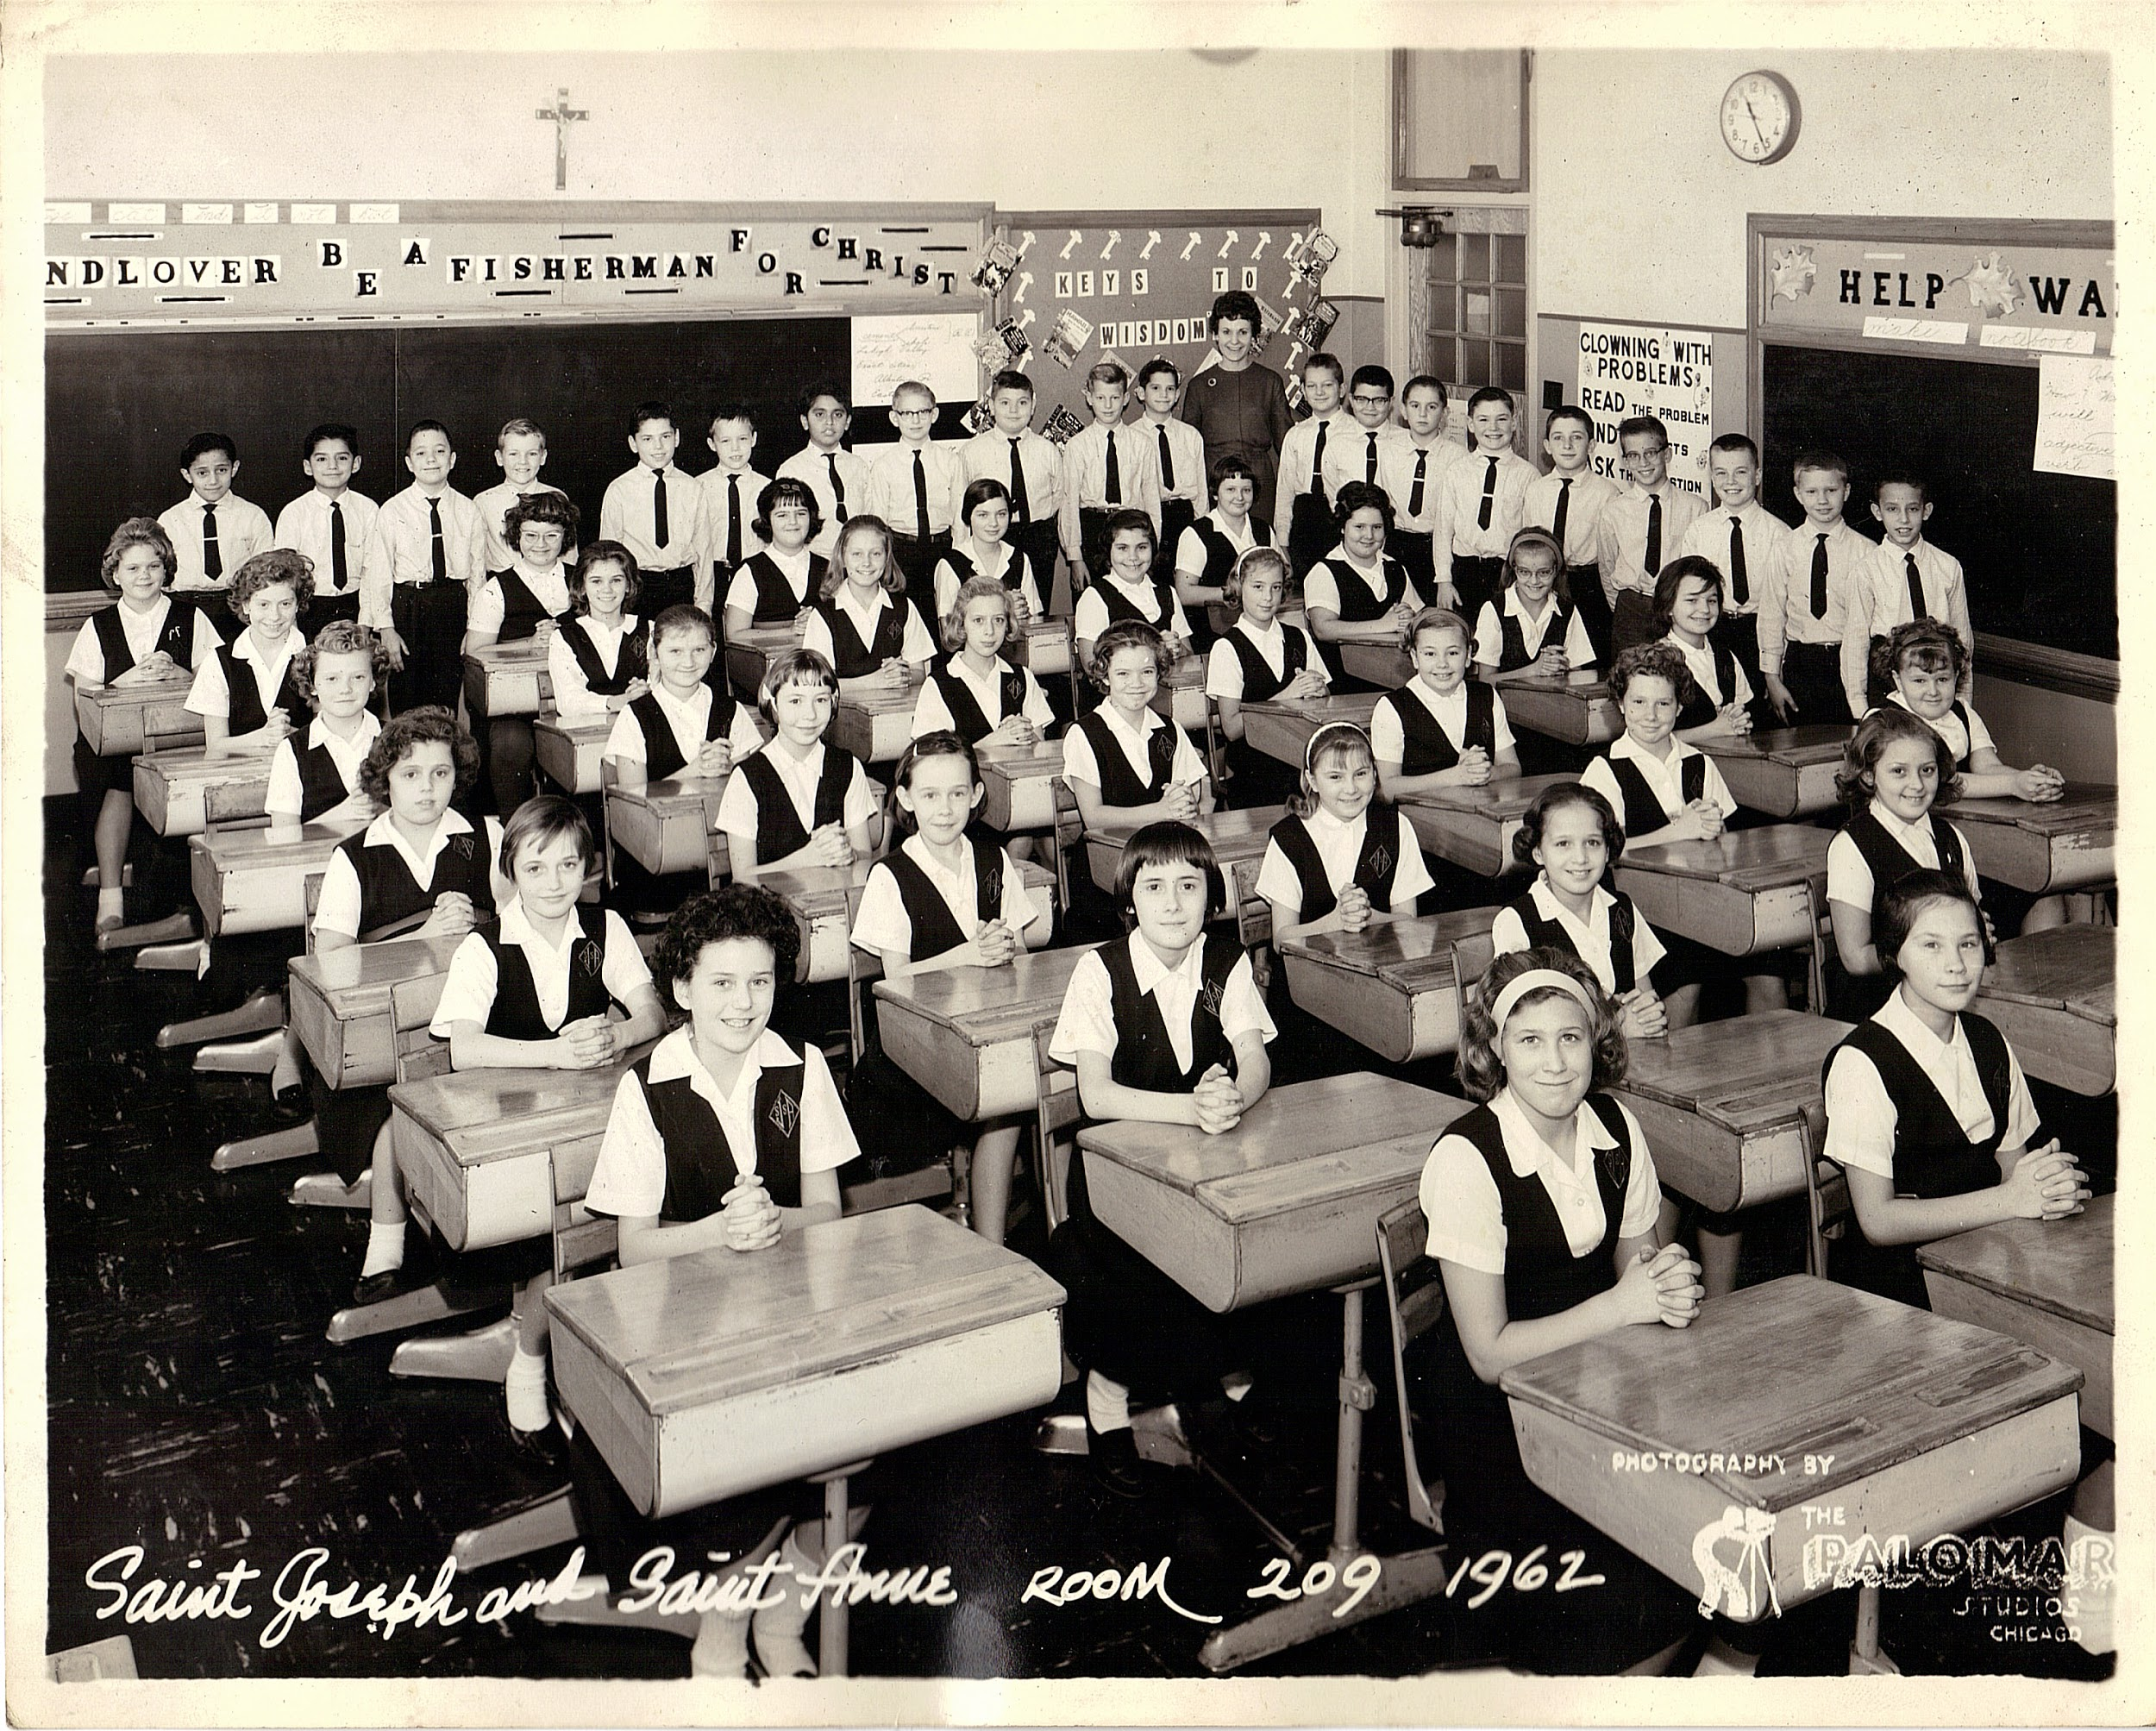
1. In your own words, explain what conformity is in two complete sentences.

2. What are two real-life conformity examples that the article provides?

3. What are some of the major reasons we conform?

PART II
Interview Conformity Analysis In a group of three to four, read the interview tips together. Afterwards, select two examples of conformity you agree with and write those down. Next, select two examples of conformity you would disagree with and explain why you disagree with these tips.

Dressing for Interviews
Before you say a single word to the interviewer, you have already made an impression based on how you’re dressed. The guidelines given here are commonly accepted as appropriate for interviewing. Every company has a different dress code; how you dress at the job may have very little to do with how you dress for an interview.
﻿Men
- Dress in a manner that is professionally appropriate to the position for which you are applying. In almost all cases, this means wearing a suit. It is rarely appropriate to “dress down” for an interview, regardless of company dress code policy. When in doubt, go conservative.
- You should wear a suit to interviews. “Suit” means the works: a matching jacket and pants, dress shirt, tie, coordinating socks and dress shoes. A dark-colored suit with light colored shirt is your best option.
- Your suit should be comfortable and fit you well so that you look and act your best. There is a difference between not yet feeling at ease in a suit and trying to fit into the same suit you wore to your sister’s wedding when you were 15. (In the latter case, it’s time to invest in a new suit!)
- Avoid loud colors and flashy ties.
- Clothing should be neat, clean, and pressed. If you don’t have an iron, either buy one or be prepared to visit the dry-cleaner’s often. Shower or bathe the morning of the interview. Wear deodorant. Don’t wear cologne or aftershave. You don’t want to smell overpowering or worse, cause an allergic reaction.
- Make sure you have fresh breath. Brush your teeth before you leave for the interview, and don’t eat before the interview. Don’t smoke right before an interview.
- Your hair should be neat, clean, and conservative.
While it may be appropriate to dress more casually for a second interview, you must still dress professionally. It’s much better to be too dressed up than too casual. A good rule of thumb is to dress like your boss. Shoes should be well-polished and in good condition, not scuffed or run-down at the heels. They should also match your belt. You will get a great deal of use out of a good-quality pair of dress shoes in a traditional style. Ask the salesperson at the shoe store for advice. Be sure to shave the morning of the interview, even if you don’t ordinarily shave every day. If you have a full beard or moustache it should be trimmed and neat-looking.This may sound like a lot of rules, but these are the generally acceptable guidelines you should follow when deciding what to wear to an interview. Dressing professionally shows respect for yourself, the interviewer, and the company. You may not have to dress like this every day, but you are more likely to be taken seriously when you present yourself in a professional manner and take the time to attend to details.
﻿Women
- Generally, you should wear a suit with a skirt or pants. When in doubt, be more conservative.
- Your suit should be comfortable and fit you well; if your waistband is cutting you in half or your jacket is too tight, you won’t look or act your best. Some stores offer free alterations when you purchase a suit, or you may want to find a tailor to adjust a suit you already own.
- Interview suits should be simple and dark in color. Anything tight, bright, short, or sheer should absolutely be avoided. (Interviewers have been known to complain about the length of interviewees’ skirts; if you have any doubts, it’s probably too short.) Knee-length skirts are suggested. Very long skirts, while modest, are also considered too trendy for an interview.
- Wear a conservative blouse with your suit. Do not wear bright colors, animal prints, or anything lacy, sheer, or low-cut.
- Make-up and nail polish should be understated and flattering; shades that are neutral to your skin tone are generally advisable. Avoid bright or unusual colors or very long nails.
- Keep your jewelry and hair accessories to a minimum, and stick to those that are not flashy, distracting, or shiny. One ring per hand is best.
- Shoes should be conservative and fairly low-heeled. They should be in reasonably good condition, not scuffed or run-down at the heels. Don’t wear shoes with an open toe or back; any shoes you would wear on a date or to a club are probably inappropriate. A basic pump is flattering, versatile, and will stay in style forever (once you own pumps, you can spend the rest of your money on fun shoes). The salesperson in the shoe store can steer you in the right direction.
- Your hose should be neutral (matched to your skin tone). Make sure the heels are not dyed black from your shoes and that there are no snags or runs. Only use the nail polish trick in an emergency; you may want to carry an extra pair of hose with you instead.
- Dress in a manner that is professionally appropriate to the position for which you are applying. In almost all cases, this means wearing a suit. It is rarely appropriate to “dress down” for an interview, regardless of company dress code policy. When in doubt, go conservative (is this starting to sound familiar?).
- Your clothing should always be neat, clean, and pressed. If you don’t have an iron, either buy one or be prepared to visit the dry-cleaner’s often.
- Shower or bathe the morning of the interview. Wear deodorant. Don’t wear perfume: you don’t want to smell overpowering or worse, cause an allergic reaction.
- Make sure you have fresh breath. Brush your teeth before you leave for the interview, and don’t eat or smoke before the interview.
- Your hair should be neat, clean, and conservatively styled. Banana clips, brightly-colored scrunchies or elastics, and cheerleader-type ponytails look out of place with a suit. You may want to wear your hair in an updo, pull it back into a low ponytail, or wear a barrette (this suggestion does not include the tiny little barrettes that only hold the front of your bangs back). The idea is to look polished and professional, not to advertise what a creative genius your hairdresser is.
While it may be appropriate to dress more casually for a second interview, you must still dress professionally. It’s much better to be too dressed up than too casual. This may sound like a lot of rules, but these are the generally acceptable guidelines you should follow when deciding what to wear to an interview. Dressing professionally shows respect for yourself, the interviewer, and the company. You may not have to dress like this everyday, but you are more likely to be taken seriously when you present yourself in a professional manner and take the time to attend to details.

In Your Groups Discuss the Following:
TIPS WE AGREE WITH:  1.)  2.) | TIPS WE DISAGREE WITH:  1.)  2.)

